Reviewers' comments:
Reviewer 1: Experiments were well conducted and results are clear. I don't have any major concerns except from asking more clarifications.

We would like to thank the reviewer for their time and review of our manuscript. Their request for clarification highlighted some oversights on our part and improved the overall quality of the manuscript. Below are our responses to the reviewer’s comments.
General/presentation
I believe the presentations could be improved, maybe (but it is just a suggestion) by labeling the branches in the model (Fig4) or giving box modules "names" instead of equations and then describing what is in each box.

We agree with the reviewer that Figure 4 could be difficult to understand and have redesigned the figure to simplify it and include labels within each box. We have also updated the figure caption to read as follows:

A simplified diagram of the two-stage contrast gain control model with parallel monocular and phase-selective channels. This diagram represents the processing stages of the positive phase channel in the left eye. These operations are identical for the other channels (negative phase left eye, positive and negative phase right eye) of the model. The sinusoidal input to the left eye ($c_{L}^{+}$) is fed through the first stage of the parallel monocular channel and the monocular stage of the binocular channel, which both apply a non-linearity to the input (m) and divisive inhibition (i.e., contrast gain control). The monocular stage of the binocular channel receives suppression from itself and the positive phase channel from the other eye. The output of these stages is fed into a second contrast gain control stage. It is at this stage that the monocular inputs are combined in the binocular channel. Finally, all responses are fast Fourier Transformed and their absolute values are summed over phase selectivity, followed by a sum over ocularity (binocular and monocular responses). This approach to defining the model's output differs from that of Georgeson (2016) to account for methodological differences. A pink noise spectrum was added to facilitate a comparable calculation of model SNRs, as is done with human data.
Anyhow, the variables used in all equations should be fully explained (e.g. what is Rb in eq1; what is S in eq2; what are R, Z in eq3, etc…)
We thank the reviewer for their thorough examination of the paper and for catching the missing parameter description in some equations. Parameter descriptions have been added to equations 1, 2, and 3 (see red text in updated manuscript). We have also included parameter descriptions in the modelling section and referenced other equations that contain the same parameters.
Using two different types of counterphase and on/off stimuli is an important feature for evaluating the model. The rationale for using these two types of stimuli should be explained in the introduction.
We agree with the reviewer, the rationale for the two types of stimulus flicker could have been clarified in the introduction. We added a paragraph to explain why both the On/Off and counterphase presentation procedures were used (copied below). We had initially hoped that both stimulation protocols would provide complementary data for model selection. However, that was not the case as all models, except for the evidently wrong ones, were able to explain SNRs from the counterphase condition relatively equally.

Steady-State Visually Evoked Potentials offer a unique opportunity to bridge the gap between models developed from psychophysical data and neuroimaging, as responses to stimulus contrast (i.e., SSVEP amplitude) are directly associated with behavioral sensitivity to contrast (Norcia, 2015; Wade & Baker, 2025). Two common stimulus presentation protocols are used to generate SSVEPs: a sinusoidal On/Off flicker, where the stimulus alternates between a blank background (0\% contrast) and the peak contrast, and sinusoidal counterphase flicker, where the stimulus alternates in phase (i.e., the black regions become white, and the white regions become black). On/Off flicker activates different populations of on and off-cells independently once per cycle, generating frequency-following responses at the frequency of the sinusoidal modulation (1F). On/Off flicker can also generate SSVEPs at the odd and even integer harmonics (2F, 3F, 4F, etc.), which reflect nonlinear processing in the visual system (Regan, 1988). Counterphase flicker will generate two transients per cycle, resulting in SSVEPs at the even harmonics of the flicker frequency (2F, 4F, 6F, etc.). These frequency-doubling responses are argued to provide a cleaner measure of nonlinear visual responses (Kim et al., 2011; Skottun, 2007). Utilizing both stimulation protocols enables a comprehensive description of linear and nonlinear visual processes, thereby generating the data necessary to evaluate psychophysical models of visual perception.

We have also included a statement at the beginning of the second paragraph in the discussion to emphasize our findings that the stimulus phase (spatial and temporal) generated the necessary data to select the best model. The text is as follows:

Our data proved useful in selecting the best-performing model, albeit in an unexpected way. The stimulus presentation protocols (On/Off and counterphase) individually were unable to discern the best model, as all models, except the evidently wrong ones, were able to capture neural responses to counterphase stimuli. Instead, it was the spatial and temporal phase of our stimuli that proved most useful in model selection.
Admittedly, the authors have worked extensively on this topic. I still think there are a lot of autocitations, and referencing a bit more the work from other groups could be beneficial.
We thank the author for suggesting the addition of work from other groups. We cite material as is relevant to support the narrative of this manuscript. While we do cite other groups in the introduction, the primary focus of this paper was to evaluate the two-stage contrast gain control model using a complex set of neuroimaging data. We therefore concentrate our referencing on work relevant to this model.
Methods
Give more details about participants: age range, sex, stereo vision.
We have added a sentence in the participant section to clarify their age range, sex, and stereovision:

Fifteen observers (N_{male} = 4; age range [19 34]), including authors BR and DHB, participated in this study. All observers had normal or corrected-to-normal visual acuity, as verified by a Snellen chart, and normal binocular vision, as verified by a Titmus test.
Was the surrounding texture constant throughout the experiment?
The surrounding texture was constant during a trial, but its phase was changed across trials. We have included a sentence in the stimulus creation section to clarify this point.

The surrounding texture was fixed during a trial, but its phase structure was changed across trials.
Which software was used for stimulus presentation?
All stimuli were created in MATLAB, and presented using Psychtoolbox. We included a sentence in the stimulus creation section to clarify this point.
All stimuli were generated using MATLAB (MathWorks, Natick, MA) and presented to observers using Psychtoolbox.

Minor
L1: "Binocular vision fuses similar inputs" change to "compatible inputs"
Changed
L250: "While the median SNRs under On/Off flicker shown in temporal anti-phase were reduced in comparison to other conditions, both the spatial in phase temporal anti-phase condition ( < .001) and the spatial and temporal anti-phase conditions ( = .004) had median SNR values that were statistically significantly greater than 1.0." grammar?
We have changed the sentence to:
The median SNRs of temporal anti-phase stimuli under On/Off flicker, while smaller than those of other conditions, were nevertheless statistically significantly greater than 1.0 (spatial in-phase: p < .001 and spatial anti-phase: p = .004).

It is hard to say which is green and which is brown in Fig5.

We have updated the color palette for this manuscript to be more easily discerned.
For the counterphase stimulus, sometimes 6Hz is considered fundamental (as in Fig3 caption As in A, boxplots show participant SNRs at 6Hz, the fundamental frequency for counterphase flicker.) or as 1st harmonic as in line 427 (counterphase flicker generated responses at twice the fundamental frequency (6Hz)). Please make sure you keep a consistent definition (check at other places as well)
The figure has been adjusted to refer to the fundamental frequency of our stimulation protocol to be 3Hz, and we have gone through the manuscript to ensure this is consistent. The caption now begins with :
Boxplots of participant SNRs at the fundamental frequency (3Hz) under On/Off stimulation and its second harmonic for counterphase stimulation.

Reviewer 2: Comments below in decreasing order of importance.
We would like to thank the reviewer for their time and review of our manuscript. Below are our responses to their comments.
1. Sensitivity is implicitly limited by effectively late noise in all of the models examined in this manuscript. By "effectively late," I mean either that it is added after signals from the two eyes have been combined or that stochastic signals in the two eyes are perfectly correlated. This implicit limitation stands in distinction to the model of Campbell and Green (1965), in which fluctuations in the two eyes' signals are assumed to be independent. Is there any evidence that sensitivity is, indeed, limited by effectively late noise?

The reviewer is correct that sensitivity in our models is implicitly limited by late noise, as is assumed by all contemporary models of binocular vision, which distinguishes it from the model by Campbell and Green. However, it has been clear for some time now that the proposed architecture by Campbell and Green does not capture the behavioral results of binocular summation. Their model can only return sqrt(2) improvements if the noise from the unstimulated eye is ignored on monocular trials. As participants have no way of knowing which trials are monocular and which are binocular, we can’t effectively predict observer responses with this model. It is conceivable that models could be created by assuming early noise; however, it would be complicated for them to explain the wide range of results that are accounted for by current models, such as the one we present here.
2. Reducing the SSVEPs to SNRs would be sensible if 'noise' were constant across conditions and frequencies. Otherwise, I think that signal and noise should be reported separately. Ideally, the effects of condition and/or frequency on noise as well as signal should be explained.
We appreciate the reviewer’s interest in the study of internal noise and agree that noise can be an interesting aspect to investigate. We use SNRs in this experiment to compare the magnitude of multiple frequencies within a condition. The amplitude spectrum of EEG signals is pink; thus, low frequencies will have a larger amplitude than higher frequencies, which prevents a direct comparison. SNRs circumvent this issue as they are relative measures of amplitude.

We appreciate the concern regarding the potential difference in amplitudes at neighboring frequencies to the fundamental and its harmonics, which may vary across conditions. This could indeed alter SNRs and make their comparison difficult. We conducted permutation tests to ensure sure there are no differences in the amplitude of the noise frequencies used in the denominator of our SNR calculations. As expected, no statistically significant differences in the amplitude of the 10 neighboring frequencies used in the denominator of our SNR calculations were found across conditions (all ps were greater than 0.05). Below is a figure that shows the distribution (across participants) of the noise amplitudes. As you can see, all distributions overlap significantly.
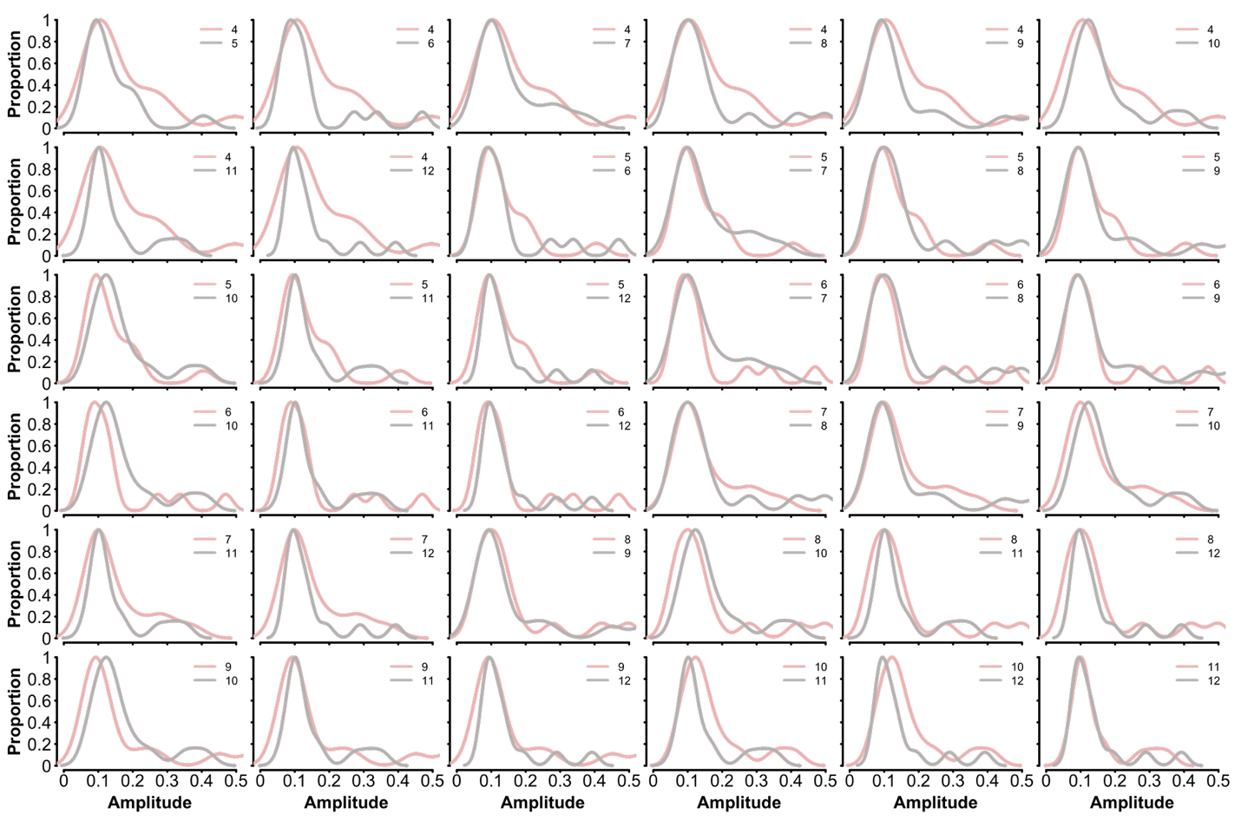

We cannot compare amplitudes across frequencies because the amplitude spectrum of EEG signals is pink, and therefore, low frequencies by default will have greater amplitude than higher frequencies.
3. Calculation of AIC requires likelihood estimation. How was that accomplished? It would be nice to know how many free parameters were associated with each model.

The reviewer is correct; AIC is calculated using the likelihood, but one can also estimate the likelihood using the mean square error. This is the method we use in the manuscript. The equation we use is: AIC = 2*k+ n*log(mse) + n*log(2*pi) + n. k refers to the number of parameters in the model, n is the sample size, and mse is the mean square error (sum of the squared differences between model and real data divided by the sample size).
4. Data from all observers seem to have been pooled to achieve significant effects (including p just less than .05). How can we be sure that the sample size of N = 15 wasn't the result of p-hacking?
We thank the reviewer for their comment on our statistical analysis. They are correct; we aggregate observer data into a distribution of SNR values for each condition. Statistical tests compare measures of central tendency for distributions, which means SNR values of our observers must be pooled to build this distribution. As with any data and statistical test, the goal is to estimate the central tendency of a sampling distribution (in this case, the SNR values for various stimulus configurations). The larger the sample size, the better the estimate of central tendency (and the smaller the variance in our estimate will be). This is why we have a sample size of 15 observers. Experiments that use the SSVEP method generally have a sample size of 10 or more. This is to ensure a good estimate of the statistic of interest (e.g., median SNRs).

Additionally, our experiment code, data, processing pipeline, and analysis are all available on the OSF website, and a computationally reproducible version of our manuscript is available on GitHub. Note that this study was conducted before our lab routinely preregistered experiments, and the analysis was conducted many years after data collection. Our analyses did not dictate sample size.
5. Legge (1984a) is cited in reference to Eqn. 1, but I can't find that equation anywhere in Legge's paper.

This was an oversight on our part; the equation is in Legge 1984b. We have changed the citation.
6. "...can improve by a factor of root 2 or more" in the third sentence seems meaningless.

This sentence refers to the effects of binocular summation at threshold, where the doubling of the input increases performance by a factor of 1.41. It is fundamental to the computational description of binocular summation (the non-linearity of summation) and is regularly used as an opening statement in manuscripts that discuss binocular summation.

